Hotel management system

Software requirement specification Version 1.0

Applied Science University

Software Development and Documentation

Revision History

|  |  |  |  |
| --- | --- | --- | --- |
| Version | Author | Date | Description |
| 1 | Musaab Alfalahi | 12-11-2023 | The initial SRS for Hotel management system |

Contents

Introduction 2

System overview 2

Stakeholder Information 2

Context Diagram 3

Use Case Diagram 3

Functional Requirements 4

Quality Attributes 4

System Constrains 5

# Introduction

This is a user-friendly Hotel Management System! It's like your personal assistant for booking hotel rooms and keeping everything organized. Easy reservations and smooth management – making your hotel experience simpler than ever.

# System overview

Our Hotel Management System is a user-friendly desktop application designed to simplify hotel operations. It facilitates easy room bookings for guests and provides administrators with tools for efficient reservation management, billing, and room status tracking. The system ensures a personalized experience for guests, with detailed profiles and secure handling of information. With straightforward reporting and analytics, our system empowers hotel owners to make informed decisions for improved performance. It's a comprehensive solution that enhances both guest satisfaction and administrative efficiency.

# Stakeholder Information

* End Users: customers who use the application to book rooms.
* Application Administrators: Responsible for system maintenance and monitoring.
* Developers: The team responsible for developing and maintaining the application.

# Context Diagram

# Use Case Diagram

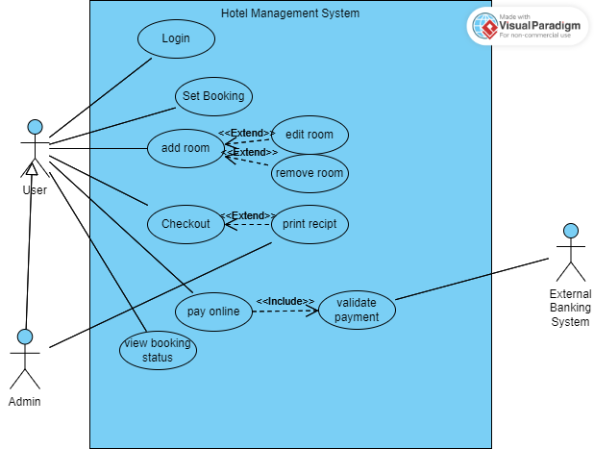

# Functional Requirements

1. The user shall login to the system.

1.1 The user shall enter their username.

1.2 The user shall enter their password.

2. The user shall set a new booking.

3. The user shall add rooms to their booking.

3.1 The user shall edit booking rooms.

3.2 The user shall delete booking rooms.

4. The user shall checkout his booking.

4.1 The system admin shall print receipt for the customer booking.

5. The user shall view their booking status.

6. The user shall pay online for their booking.

6.1 The external banking system shall validate customer payment.

# Quality Attributes

1. Usability: The Hotel Management System prioritizes usability, ensuring an intuitive and user-friendly interface for both guests and administrators. With straightforward navigation and easily accessible features, the system enhances overall user experience, reducing the learning curve and facilitating efficient utilization.
2. Reliability: The system is built to be reliable, providing consistent and dependable performance. From accurate booking processes to secure data handling, users can rely on the system for smooth hotel operations, contributing to a trustworthy and dependable service environment.
3. Scalability: Designed to accommodate the evolving needs of hotels, the system is highly scalable. It can seamlessly adapt to an increasing volume of bookings, expanding the range of features and capabilities without compromising performance. This scalability ensures long-term viability for hotels of varying sizes.
4. Security: Security is a paramount concern, and the Hotel Management System prioritizes the protection of sensitive data. Robust authentication measures and encryption protocols are implemented to safeguard guest and administrative information, maintaining the confidentiality and integrity of the system.

# System Constrains

1. Hardware Limitations: The Hotel Management System is subject to the hardware constraints of the devices it operates on. Compatibility and performance may vary based on the specifications of the desktop systems used by both guests and administrators.
2. Network Dependency: The system relies on network connectivity for various functions, including real-time booking updates and data synchronization. Any disruptions or limitations in network availability may impact the system's responsiveness and functionality.
3. Software Dependencies: The system may have dependencies on specific software versions, libraries, or frameworks. Changes or updates to these dependencies may affect the system's stability and performance, requiring careful management of software versions.